|  |  |  |  |  |  |  |  |  |
| --- | --- | --- | --- | --- | --- | --- | --- | --- |
| MAD Project Evaluation 1 – Regular Intake 2020 | | | | | | | | |
| **Group Name:** | G5 Team Alpha | | **Group ID:** | G5.14 | **Batch:** | Y2S2.05 | | |
| Student ID | Student Name | Consistency (Out of 2) | Appropriateness and Professionalism (Out of 3) | Usage of resource manager (Out of 4) | Out of box design ideas (Out of 3) | Report (Out of 8) | Total (Out of 20) | Comments |
| IT19362854 | S.L Abeygunawardana |  |  |  |  |  |  |  |
| IT19000336 | I.G.M.J Mudannayake |  |  |  |  |  |  |
| IT19009728 | W.N.S Amaranayake |  |  |  |  |  |  |
| IT19210148 | R.M Wijethunga |  |  |  |  |  |  |
|  |  |  |  |  |  |  |  |

Git Repository Link: <https://github.com/Sandun01/MAD_Project.git>

----------------------------------------------------------------------------------------------------------For Evaluators use only---------------------------------------------------------------------------------------------

Evaluator’s name:

Others:

**“WOOF” DOG CARE APPLICATION**

**Connectivity Between Components**



**Introduction**

“Woof” is a dog care application which will be useful for dog lovers. This application provides some main functionalities to take care of dogs. Through this application, user can buy and sell dogs, buy accessories for dogs, find clinics and organizations for dogs.

* Woof Corner - To buy dogs by contacting the owner and sell dogs by adding advertisements.
* Woof Care – To find nearest clinic and book appointments by contacting the clinic
* Woof Shop – To buy accessories for dogs and get products delivered

**Individual Contributions**

**IT19362854 - S.L Abeygunawardana**

**Order management in Woofshop and Login/Registration**

**Description of the function**

* **Login and Registration**

First user can see the welcome screen of the app and then user navigates to the login activity. If user is a new user, have to register to the system by clicking on **Register now** at the bottom of the login page. Then user navigates to the registration form. Next user can fill the form and register to the system. If user is already registered user, can login using username and password. If user forget password user can reset it using **Forgot password** button.

* **Woofshop order management**

When user successfully login to the system user navigates to the **Home** activity. If user want to buy some accessories from shop user can click on **Woof Accessories** button. Then user can add items to the cart. After adding items to the cart user can view items in the cart by using cart icon on top of the screen. Then user navigates to the **Cart activity.** After that user can delete items from cart or calculate total bill using button **Calculate Bill.** Then user can confirm order by clicking **Confirm and Buy**.

After that user can view previous orders by user profile and also cancel orders using **Cancel order**. Admin can view all user orders using admin menu by clicking on **Customer orders** button.

**Notifications**

* User receive a notification message when login and after logout from the system.
* User receive a toast message after successfully placed the order and cancel order.

**Functions**

* login_activity
* Registration
* Woofshop_view_product
* Woofshop_view_cart
* Woofshop_view_bill
* Woofadmin_orders
* Woofshop_show_order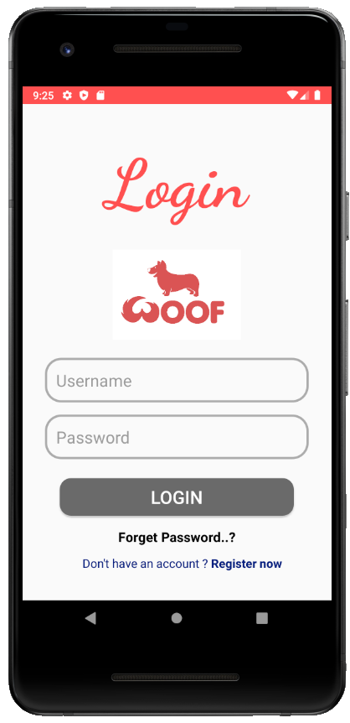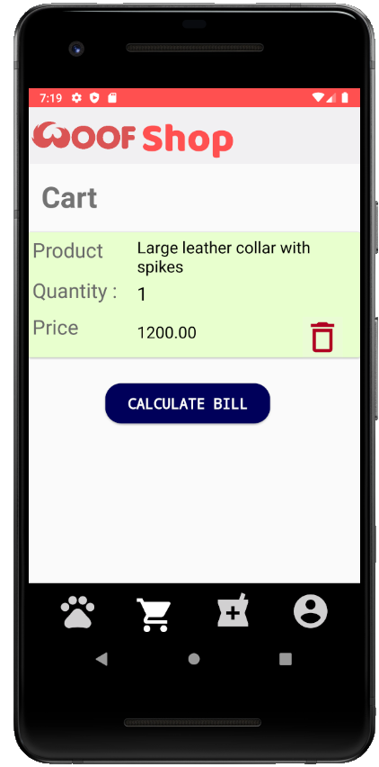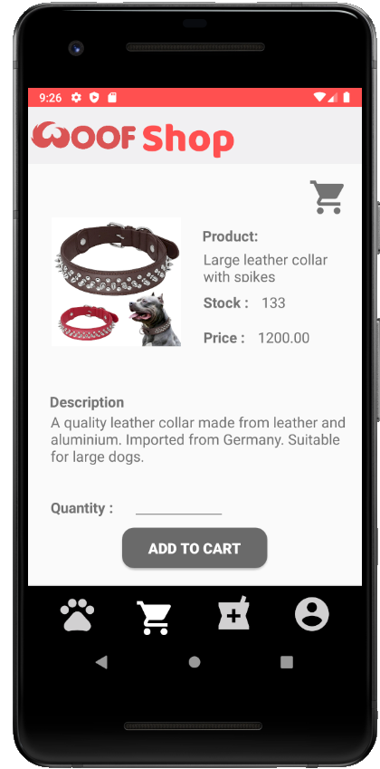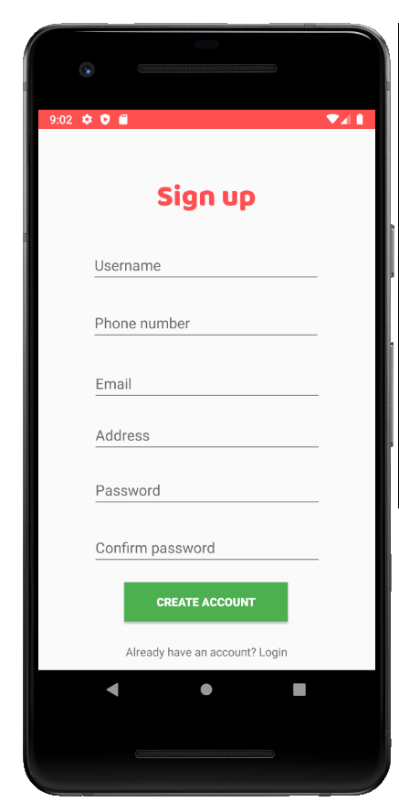s

Woofshop_view_cart

Woofshop_view_product

Registration

login_activity

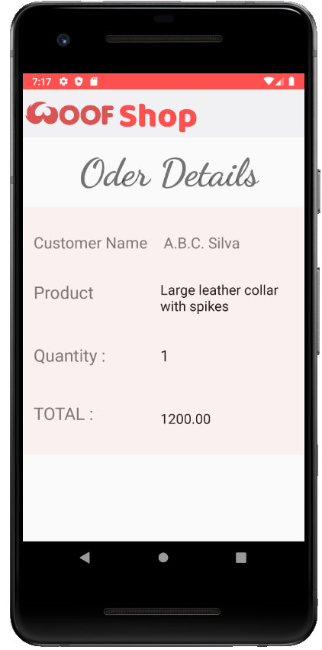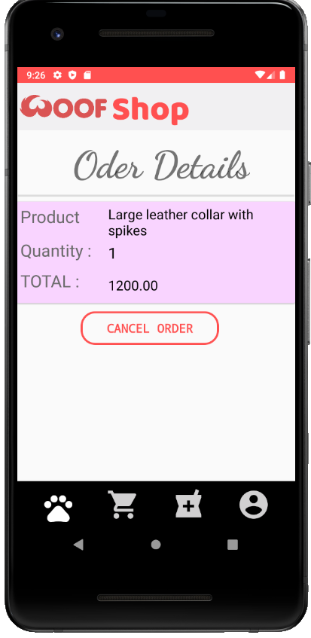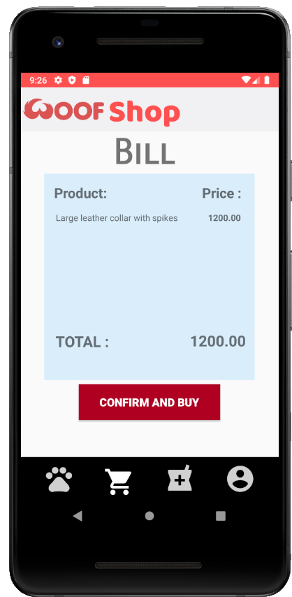

woofadmin_orders

woofshop_view_orders

woofshop_view_bil

**IT19000336 – Mudannayake I.G.M.J.**

**Woof Corner**

**Description of the functions**

The function “woof corner” is about buying and selling dogs and through user profile the user can access to different functionalities which are unique to a valid user in the application.

After login to the application as a valid user, they could be able to redirect to the advertisements page by clicking on “woof corner”. Then the User can see the advertisements of different dogs to be sold. If they need more information about a dog, they can click in view button and view more details. If someone wish to by a dog, they can press on the “call” icon or “email” icon to contact the owner.

By clicking on my Advertisements button in User profile user will be redirected to “My Advertisements” page. There they can see previously posted advertisements. They can view the advertisement using “view” icon, can edit the advertisement using” edit” icon and can delete using ‘’delete” icon. If a user wishes to sell a dog, they can post an advertisement by clicking on the “+” button in “My Advertisements” page. By filling the form and uploading a photo of the dog to be sold they can post an advertisement.

**Notifications**

* When the user clicks on the call/email icon in “woofcorner_viewad” user will get the number/email in their default mobile Dialpad/email
* When the user removes an advertisement “Advertisement deleted” pop msg will be displayed.

**Functions**

* woofcorner_show_ad
* woofconer_viewad
* woofcorner_myAds
* woofcorner_add_post
* woofcorner_view_post
* woofcorner_edit_post
* app_woofprofile_menu

**Snapshots**

woofcorner_show_Ad

Woofcorner_view_post

woofcorner_viewad

woofcorner_myAd

woofcorner_add_post

woofcorner_edit_post

app_woofprofile_menu

**IT19009728- Amaranayake W.N.S.**

**Woof Care**

**Description of the function**

After user login to the system, user will be redirects to the home page. Then they can find the nearest clinic by clicking “Woof Care” button. Then they can see the list and they can view the clinic by clicking detail page. They can contact the clinic via the “call” icon.

When admin login to the system, it will redirect admin to admin home page by clicking the “care organization” button it will redirect to organization page which shows the list of organization. By clicking “Add New Org”, admin can add new clinic details. Also, by clicking “Select” button, admin will redirect to organization details page. Admin can delete and update organization details. By clicking “Update” button admin redirect to the update organization page and save the details.

**Notifications**

* After admin updating and deleting organization details, admin receive a notification message that it has updated/deleted.
* Admin receive a notification message when add a new organization details to the system.

**Functions**

* Woofcare_clinic_details
* Woofcare_show_clinics
* Woofadmin_org_add_details
* Woofadmin_org_details
* Woofadmin_org_update
* Woofadmin_organization_view
* woofadmin_menu

**Snapshots**

Woofcare_clinic_deatils

Woofadmin_organization_viewnn

woofcare_show_clinics

Woofcare_org_add_deatilsWoofadmin

_clinic_deatils_org_add_deatils

Woofadmin_org_deatils

Woofadmin_menu

Woofadmin_org_update

Woofadmin

_clinic_deatils

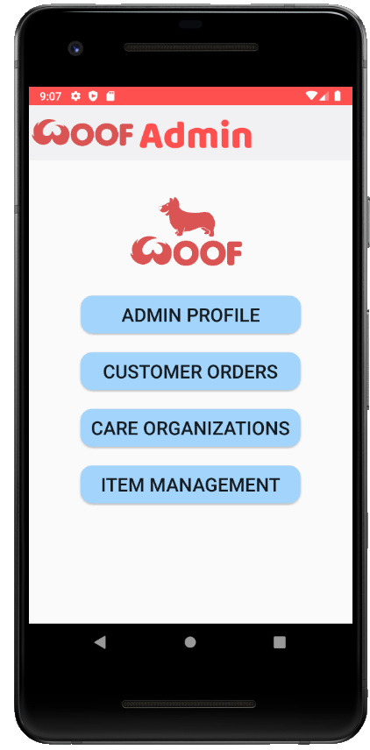

Woofadmin_menu

_clinic_deatils_org_add_deatils

Woofadmin_org_details

_clinic_deatils_org_add_deatils

Woofadmin_org_details

_clinic_deatils_org_add_deatils

**IT19210148 – Wijethunga R.M.**

**Product Management in the Woof Shop and User / Admin profile**

**Description of the function**

* **Product Management**

After signing as an administrator, they can add items to the shop by clicking the “ADD ITEM” button. When a product is added, it will be appeared in online shop with all the details also, an admin can update details about a product. When the stocks are over the admin can delete the product. After a user logged in, they can go to the online shop when they click on the “woof accessories” button. After a user is navigated to the online shop activity, they can view all the products that the admins have inserted with a preview image of the product, the price, available stock amount.

* **User profile**

After signing as a user, they can navigate to their profile via the “woof profile” button in the home. Once they are in the profile, they can edit their profile details.

* **Admin profile**

After signing as an admin, they can navigate to their profile from clicking “ADMIN PROFILE” button in the home. Once they are in the profile, they can edit their profile details. They can update their password from the admin profile

**Notifications**

* A toast message will we displayed when an item is added.
* A toast message will we displayed when users update their profile.
* A toast message will we displayed when an admin updates his profile.

**functions**

* woofshop_show_products
* woofadmin_addItem
* woofadmin_viewProduct
* woofadmin_selectedProductView
* woofprofile_update_profile
* woofprofile_view_profile
* Home

**Snapshots**

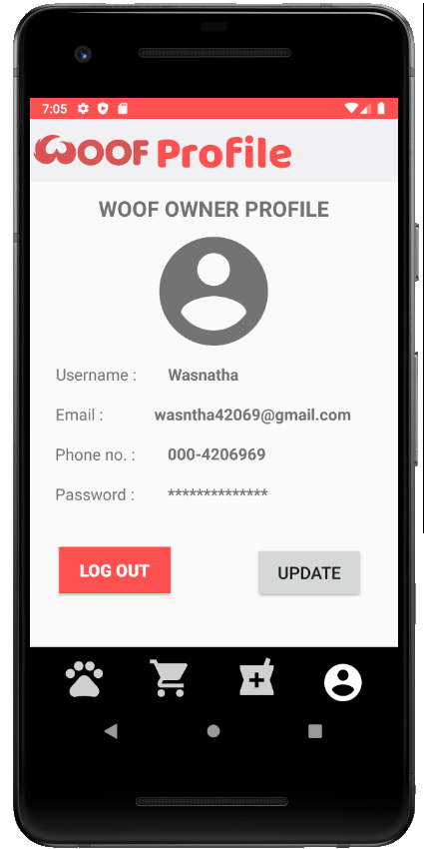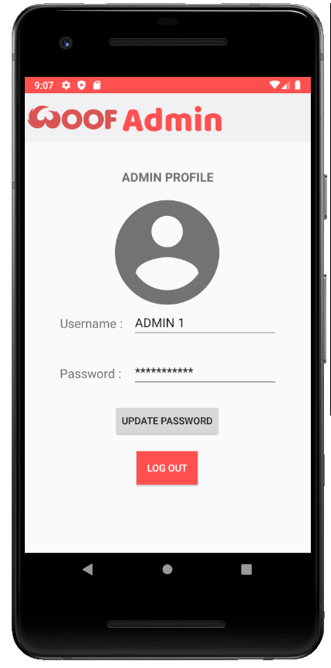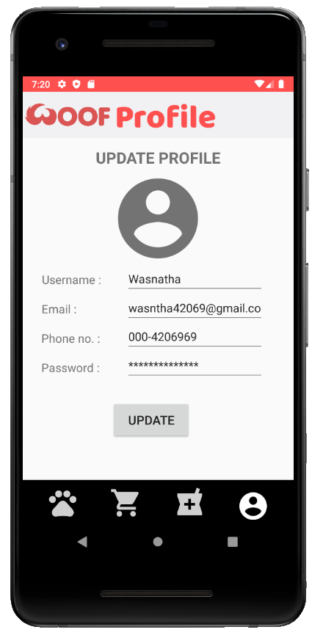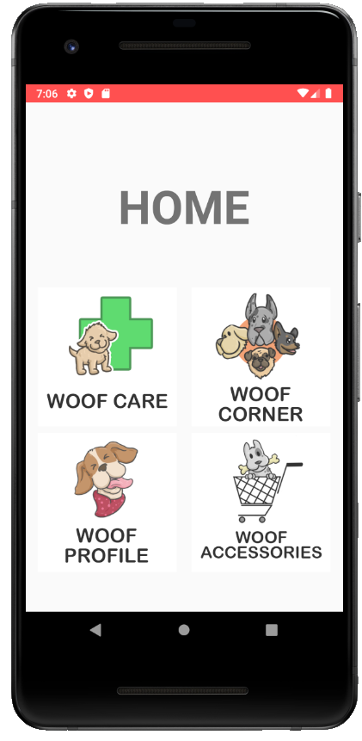

Admin_account

Home

woofprofile_view_profile

Woofprofile_update_profile

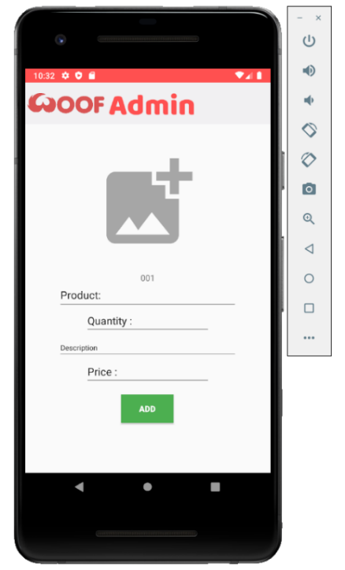

woofadmin_addItem

woofadmin_selectedProductView

woofadmin_viewProduct

woofshop_show_products

**Usage of resource files**

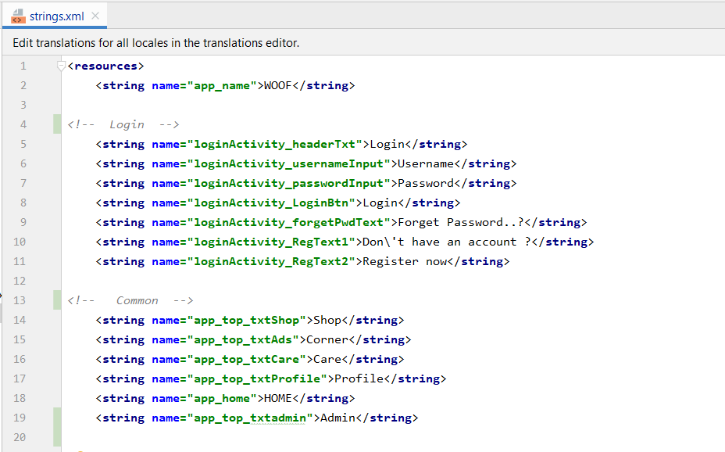**String.xml**

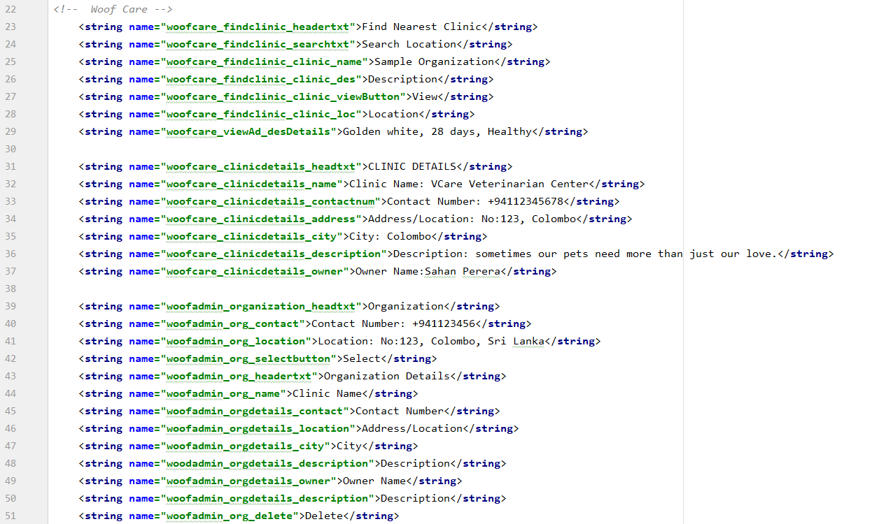

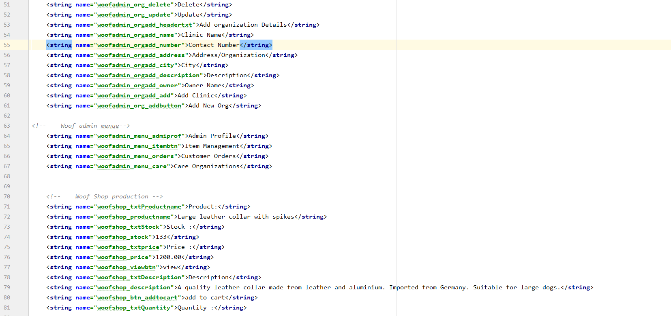

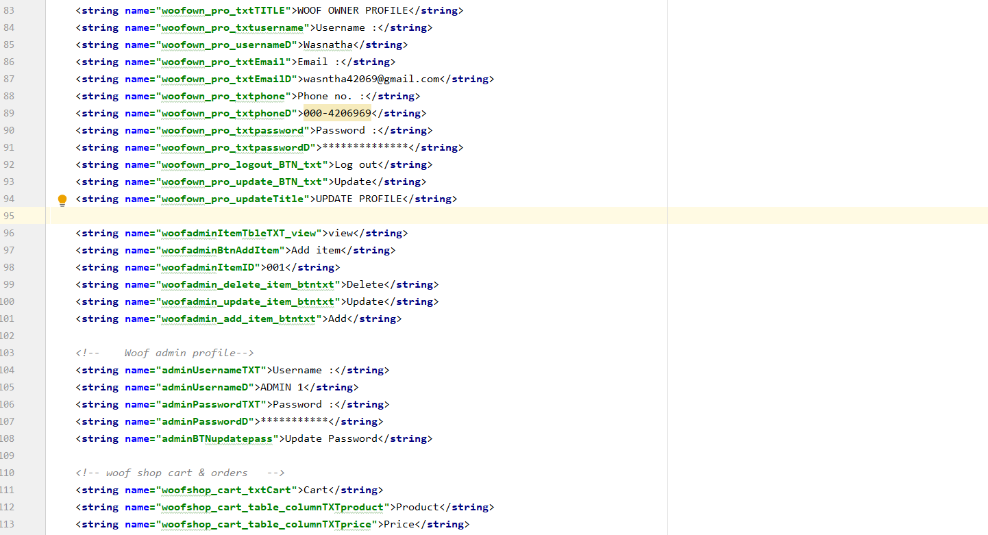

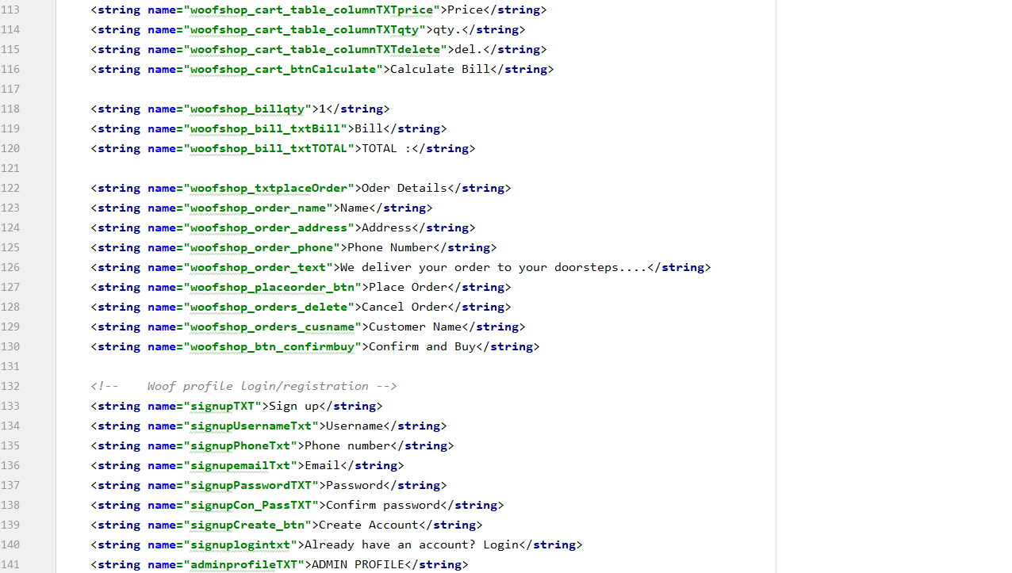

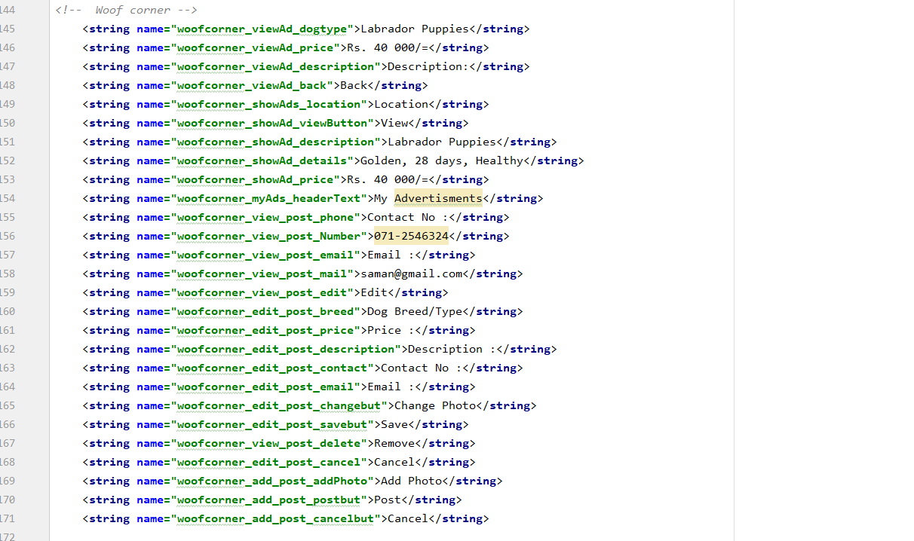

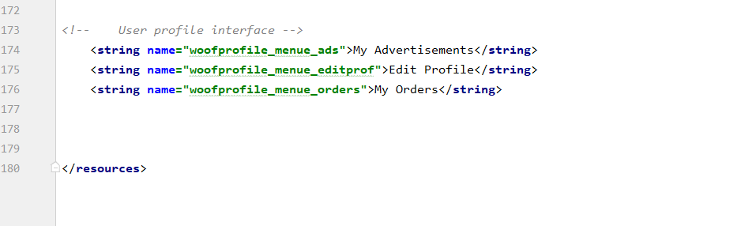

**Colors.xml**

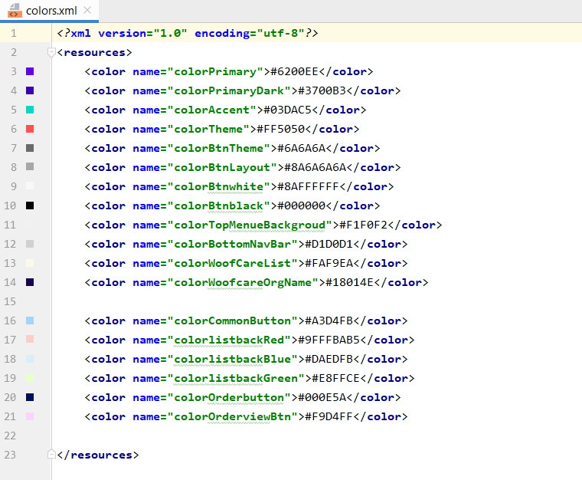

**Styles.xml**

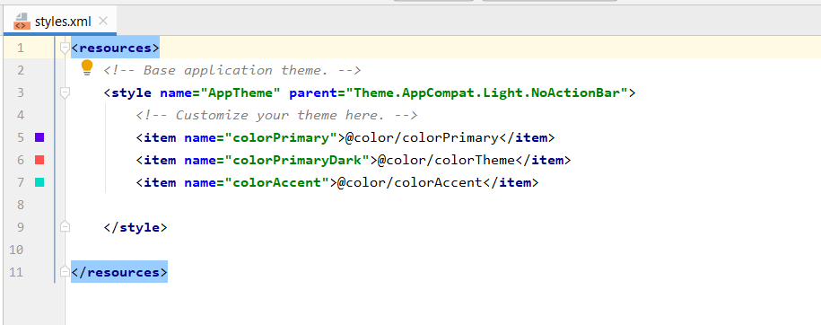

**Font Resources**

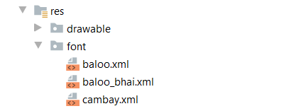

**Other Additional Technologies Used**

**Bottom Navigation bar**

Bottom navigation bar is used to navigate other activities in customer profile.

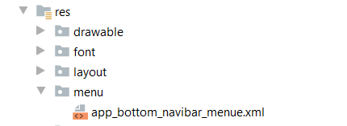

**Special Notes:** Some of the values in string.xml files are used as dummy values for demonstration purposes.